***AEC* *LAB REPORT – 9***

***OpAmp Circuits***

***NAME:*** *Khyathi Sri Basireddy*

***ROLL NO****: 2023102065*

***TABLE NO: 9***

***1.*** ***VTC for OpAmp in negative and positive feedback configurations***

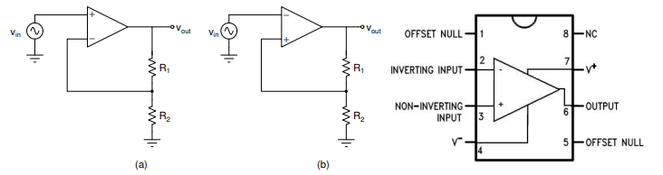

**Input Parameters:**

R1 = 10k ohm

R2 = 10k ohm

VDD = 12V  
VSS = 12V

VIN – sine wave

f = 100Hz

Vpp = VDD

**(a)**

The feedback for the circuit in Fig (a) is Negative feedback.

The feedback for the circuit in Fig (b) is Positive feedback.

**(b)**

**VTC for Negative feedback circuit:**

**When Supply Voltage = 8V**

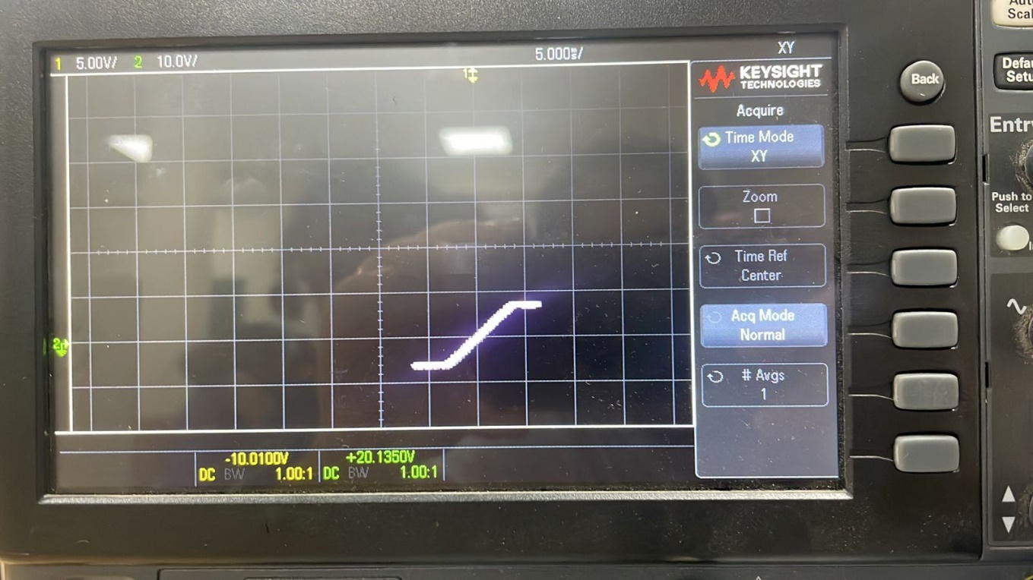

**When Supply Voltage = 12V**

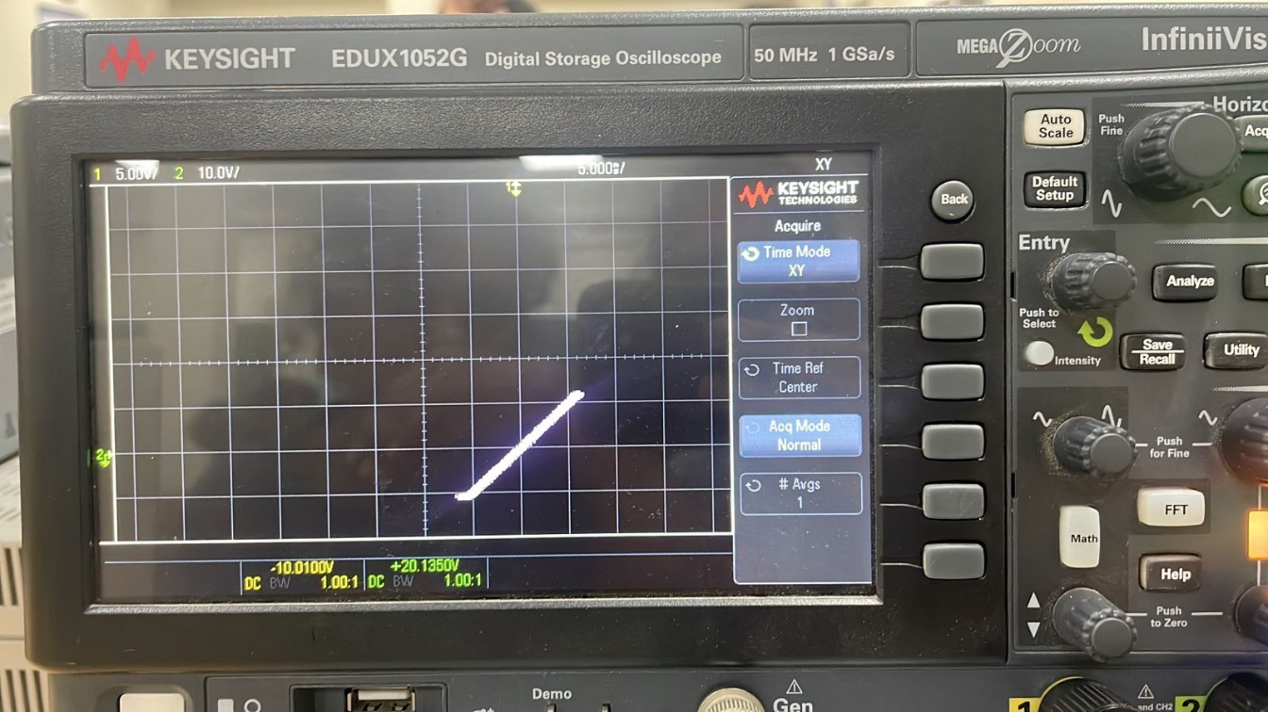

**VTC for Positive feedback circuit:**

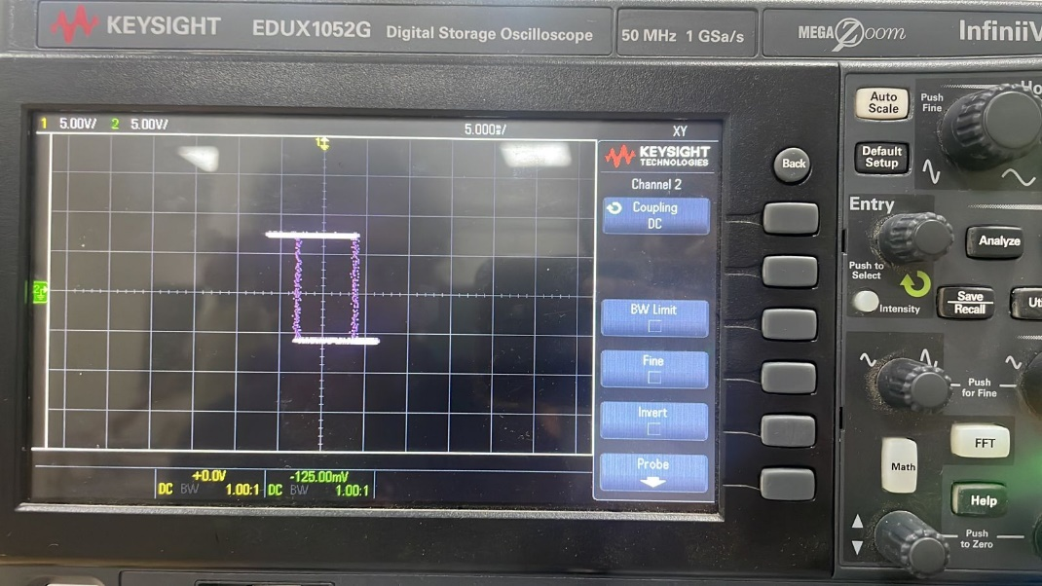

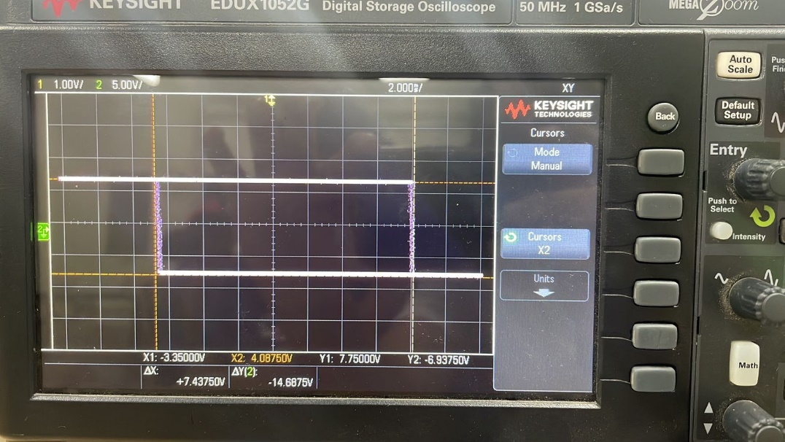

**VOUT(Green) and VIN(Yellow) for Positive Feedback Circuit:**

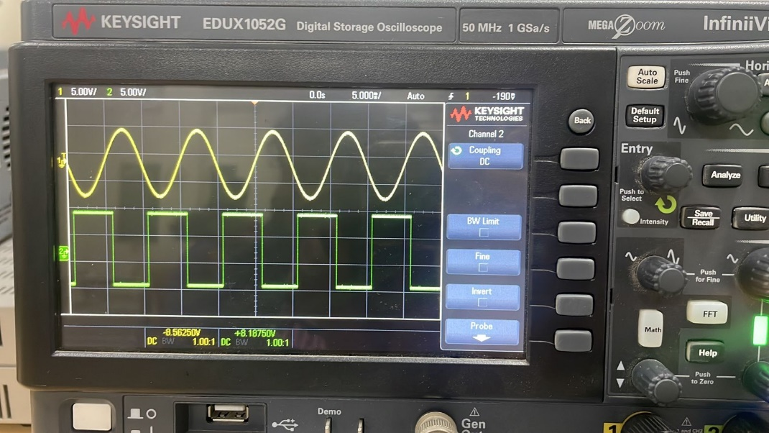

**(c)** Op Amps with positive feedback show regeneration and hysteresis, a phenomenon in which the output amplifies and prolongs the extremes of the input signal.  
Conversely, negative feedback enhances performance and stability by removing the result from the source.

* Let's start by supposing that the output of the op-amp is at one extreme, such the positive supply voltage VDD.
* The positive feedback occurs when the input voltage above the upper threshold triggers a sudden change in the output's value to the opposite extreme, such as the negative supply voltage (-VDD).
* Once the output reaches this new extreme, it needs to drop below the lower threshold in order for the output to return to its previous value.
* The OpAmp positive feedback circuit's hysteresis feature makes it possible for it to provide steady, noise-tolerant switching behaviour.
* Positive feedback strengthens the input signal, causing the output to regenerate and change states when the input voltage reaches the thresholds.

***2.RC Oscillator (+ve feedback example)***

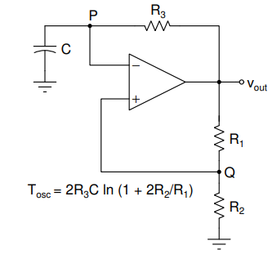

**Input Parameters:**

R1 = 10k ohm

R2 = 10k ohm

R3 = 1k ohm

C = 1 uF

VDD = 12V  
VSS = 12V

**(a) Connection and Calculations**

**TOSC Calculation:**

TOSC = 2R3C ln(1+2R2/R1)

= 2 x 1 x 103 x 2.2 x 10-6 x ln (1 + (2 x 10k / 10k))

= 4.4 x 10-3 ln(3)

= 4.83472 milli sec

fOSC = 1/TOSC

= 1 / 4.83472 milli

= 206.83 Hz

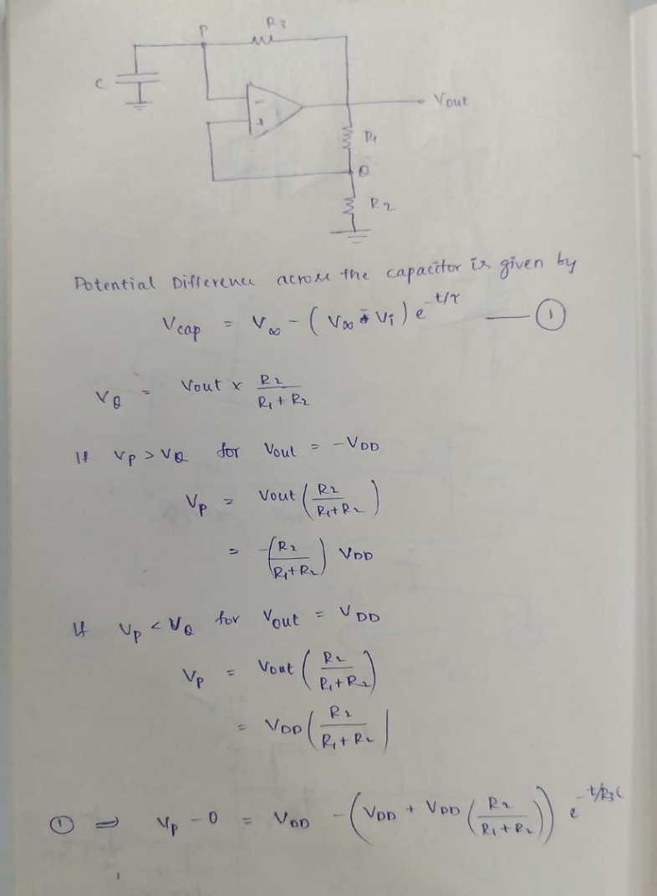

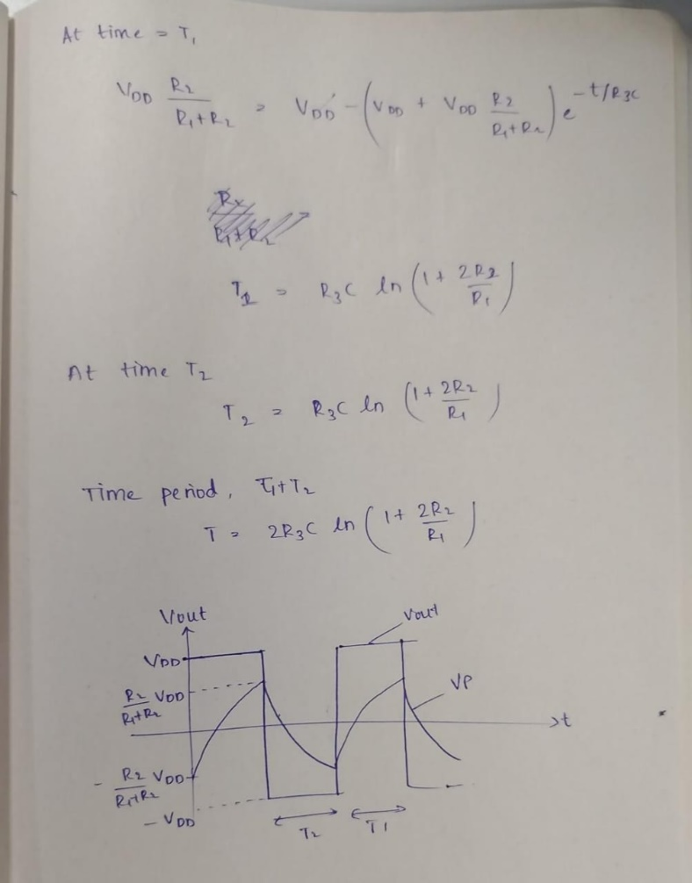

**(b) Results in the Oscilloscope**

**VP (Yellow) and VOUT(Green) wrt to Time are the below graphs**

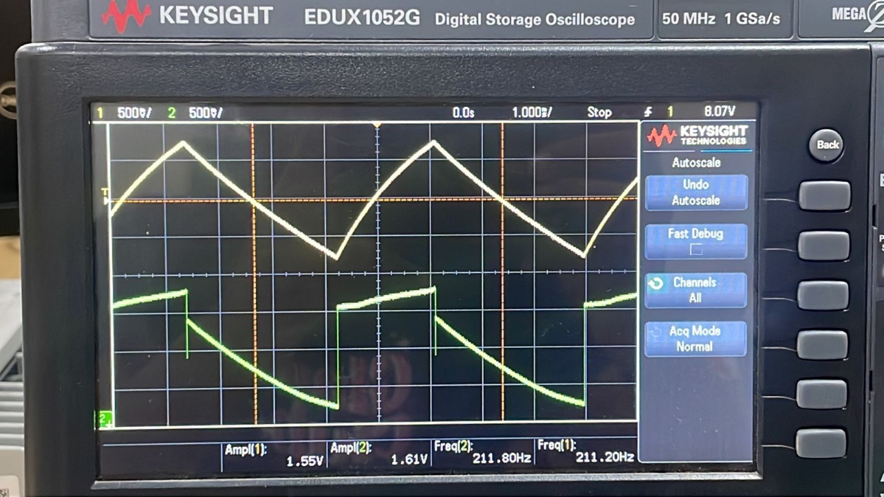

**VQ (Yellow) and VOUT(Green) wrt to Time are the below graphs**

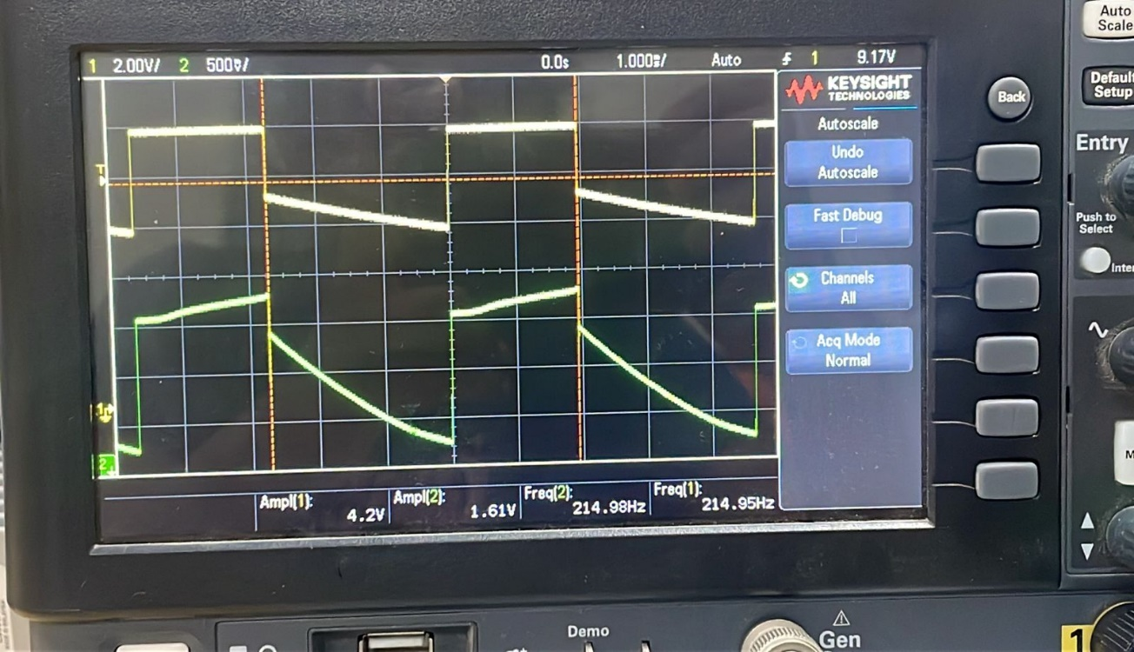

All the voltage levels are annotated at the bottom of the respective DSO plots in the pictures.

From the above graphs we can see that

The OBSERVED Frequency = 214.95 Hz

***3.Integrator (negative feedback example)***

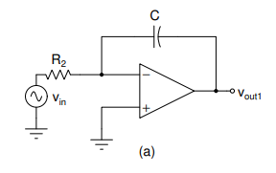

**Input Parameters:**

R2 = 10k ohm

R1 = 1k ohm

C = 1 uF

VDD = 12V  
VSS = 12V

**(a) When DC = 0V**

* Ideally, the OpAmp should not produce any output when the DC voltage is zero.
* However, Op-Amps have some internal DC offset.
* As a result of this DC offset, the input will continue to rise (integrator action, that is, integration of a constant results in a linear fluctuation in that variable.)
* The output becomes saturated if the output exceeds 12 volts, though.

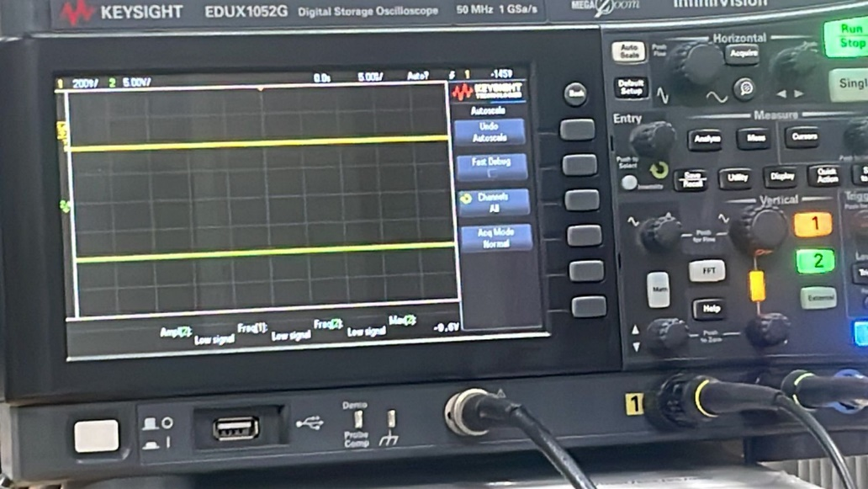

In the above we can see that Vout gets saturated at 11.7V. As time progresses, the capacitor becomes charged and starts behaving as an open circuit. This disconnection of the capacitor from the input breaks the negative feedback mechanism in the circuit.

**(b) When Resistor is connected across the Capacitor in Integrator**

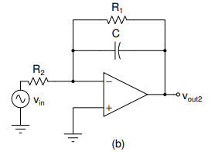

Input Parameters are as given above.

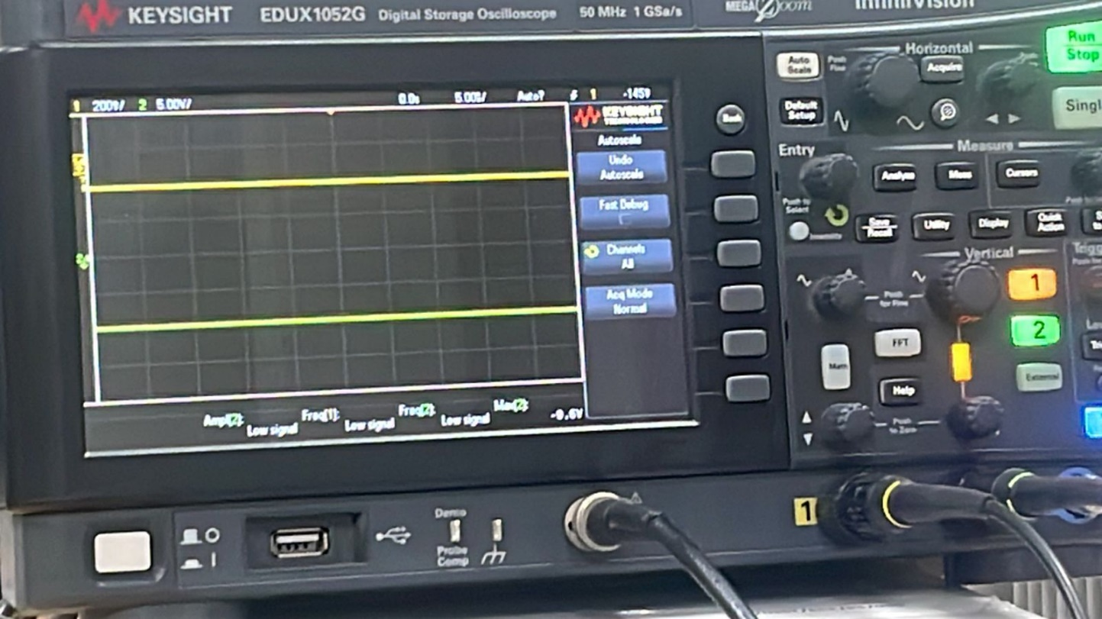

* In this configuration, the circuit acts as an integrates and outputs the integrator signal of input signal.
* However, as time passes, the capacitor gets completely charged as opAmp reaches saturation. This results in opening of the fully Charged capacitor.
* As the Capacitor is now open, the negative feedback loop is not closed.
* Hence, to maintain the negative feedback loop mechanism we keep a resistor in parallel to the capacitor so that the current has a path to flow into the resistor and maintain the loop.
* The resistor 𝑅1 plays a crucial role in ensuring that the Op Amp does not produce a saturated output by providing a continuous path for feedback.

**(c) Integration of the Square Wave**

Apply a square wave at Vin with voltage levels of 0 (low) and 500 mV (high) and frequency of

50 kHz.

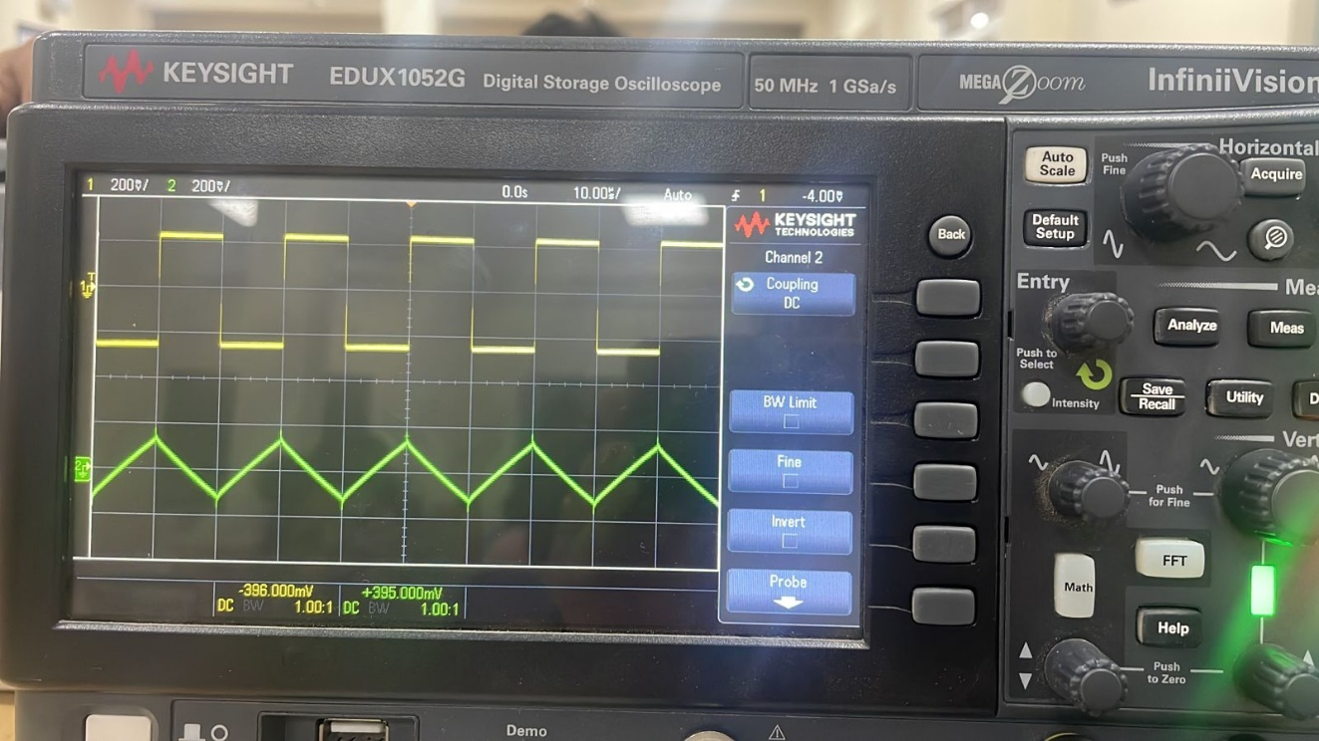

Yellow – Vin

Green – Vout

**Voltage Transfer Characteristics: (Vout2 vs Vin)**

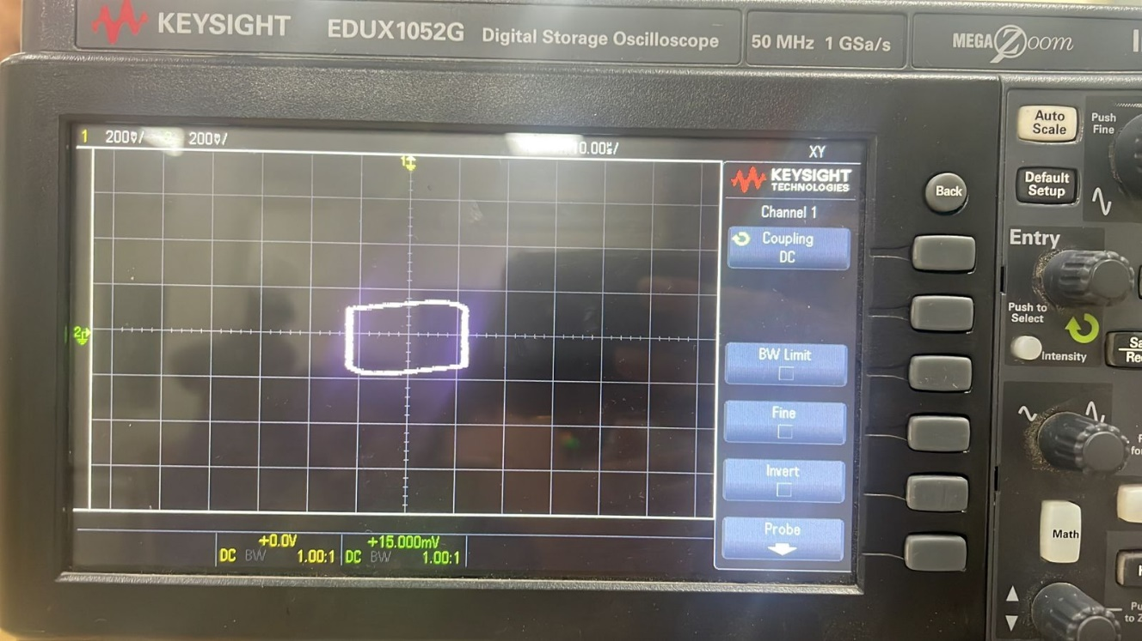

Yes, we do observe integrator action.

***4. Precision half-wave rectifier (-ve feedback example)***

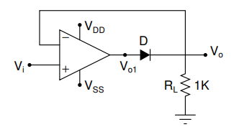

**Input Parameters:**

RL = 1k ohm

VDD = 12V  
VSS = 12V

Vin 🡪 Sine wave (Vpp = 1V, f = 100 Hz)

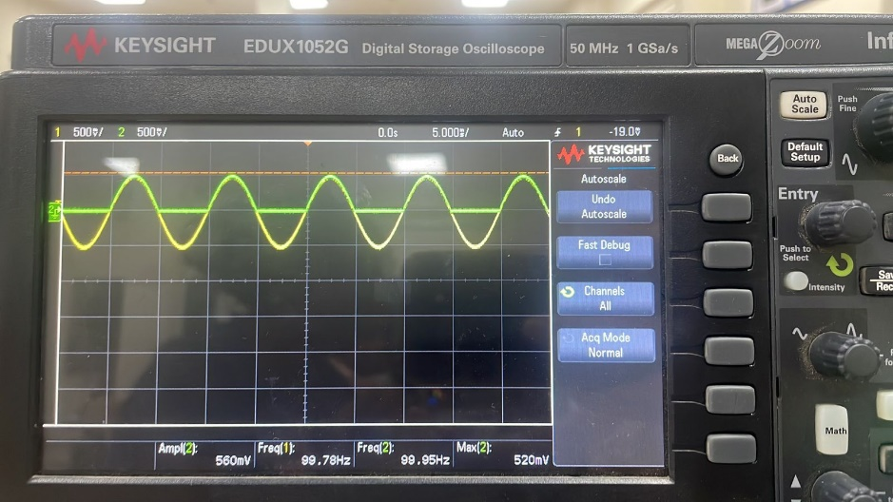

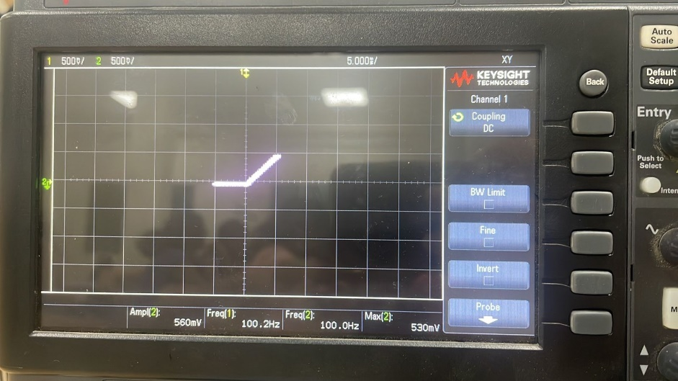

These rectifiers based on op amps are better to those based on diodes and resistors. Op-amp-based rectifiers perform better in terms of speed, accuracy, precision, input impedance, temperature stability, and linearity than diode- and resistance-based rectifiers.   
The output waveform of a traditional half-wave rectifier based on diodes has a reduced amplitude because of the diode's constant voltage drop model. The diode reduces the output sinusoid amplitude by operating as a DC voltage source with reversed polarities.

The Op Amp-based rectifier circuit, on the other hand, functions differently. The Op Amp amplifies the input sinusoid when it is positive, which causes the diode to become forward biased and function as a short circuit. Because of the virtual short between the input terminals of the Op Amp, the output voltage consequently equals the input voltage.

On the other hand, the diode is reverse biased and functions as an open circuit when the input sinusoid is negative. The output voltage drops to zero when there is no current flowing through the input terminals. The Op Amp circuit functions as a high-precision half-wave rectifier as a result.